**Formative Assignment 1**

|  |  |
| --- | --- |
| Module Name | Application Implementation (Agile Project Management) |
| Course Name | Bachelor of Technology in Software Engineering |
| Assignment Title | Project Management Plan for Implementing the community portal |

|  |  |
| --- | --- |
| Learner Name | Agung Yuda Pratama / BDSE-0922-076 |

|  |
| --- |
| Learner declaration |
| I certify that the work submitted for this assignment is my own and research sources are fully acknowledged.    Student signature: Date: 17-07-2023 |

## Purpose of this assignment

To demonstrate your capabilities in the following areas:

* Preparing Requirement Specifications
* Developing Project Plan

## Submission Format

The submission is in the form of an individual written report with examples and illustrations. This should be written in a concise, formal academic style using single spacing and font size 12.You are required to make use of headings, paragraphs, and subsections as appropriate, and all work must be supported with research and referenced using the Harvard referencing system. Please also provide a bibliography using the Harvard referencing system.

## Submission file

Submission File Name format: Cohort Code _Full Name_Assignment Number

E.g.: AIM-1222A_AliceTan_A1.docx

## Scenario

## You have been approached by ‘ABC Jobs Pte Ltd’ as a website developer to develop a community portal for Software Developers. For this module the scope is to Design, Develop, Implement & Document the data-driven website using the framework Spring Boot and react.

The Scope of the Project is to design a Community Portal Similar to Linkedin.com. Users will be able to register in the portal using the Registration Page. Users of the portal can search for other users using various parameters such as First Name, Last Name, Company Name, City & Country. Users will be able to view the Public Profile of users after searching them. The portal allow users to login, request for forgotten password and Update their profile information.

The overview of the project is below

There are 2 types of users in this Community portal. They are

1. Software Programmer
2. Administrator

## Software Programmer should be able to perform following functions in the portal

## 1. Allow the programmers to register in the portal, show a thank you page & send a registration confirmation email.

## 2. Search & Find Other Programmers after login and view their profiles.

## 3. Provide Login Page

## 4. Provide password retrieval functionality.

## 5. Update their Profile after logging in.

## Following Functionality is part of Database Design & Will be enhanced as features as required in the Capstone Project, Depending on time availability.

## 6. Send Messages to Each Other on the Portal

## 7. Create Threads & Post Replies to a Thread

## 8. Post Job Opportunities in the Portal

## The administrator should be able to perform following functions in the portal

## 1. Administer user data.

## 2. Send bulk email inviting programmers to register on the community portal

## The portal consists of the following Key pages (For Reference)

## 1. Community Portal Home Page

## 2. Registration Page

## 3. Registration Confirmation Page

## 4. Update Profile Page

## 5. Search Users Page

## 6. List Search Results

## 7. Public Profile Page

## 8. Registration Confirmation Email

## 9. Login Page

## 10. Forget Password Page

## 11. Design the Forget Password Confirmation Page

## Following Functionality is part of Database Design & Will be enhanced as features as required in the Capstone Project, Depending on time availability.

## 

## 12. Send Messages

## 13. Read Messages

## 14. Post in Message Board

## 15. List Message Board

## 16. Read A Thread

## 17. Post Job Opportunities

## 18. List Job Opportunities & Responses

## You will be required to:

* Write a brief requirement specification for the Community Portal.
* Prepare the detailed project plan to implement the Community Portal

## Evidence to exhibit

* Requirements Specification
* Project Plan

# **Write a brief requirement specification for the Community Portal.**

## **Functional Requirements**

|  |  |  |  |
| --- | --- | --- | --- |
| No | Requirements | Web Page / Process | Field detail |
| 1. 1 | Users can register their data on the register page. | Registration | Logo, Registration Image, Form Fields, Hyperlinks, Buttons, Copyright. |
|  | Users can get a confirmation message after registration. | Registration Confirm | Button, Message field. |
| 1. 2 | Users can log in with data already in the database. | Login | Logo, Login Image, Text Fields, Hyperlinks, Buttons, Copyright. |
| 1. 3 | Users can forget passwords to change passwords so users can re-enter the system. | Forget Password | Logo, Input Fields, Button, Copyright. |
| 1. 4 | Users can Update Profiles when successfully logged into the system. Users can add Education and Experience. | Update Profile | Biodata Section, Education Section, Experience Section, Button, Name Section, Background Image, Footer, and Copyright. |
| 1. 5 | Users can search for other users. | Search | Search Field, Search Button, Search Results Page, Profile Preview Section. |
|  | Users can see the search result. | Search Result | List of Profiles, See Profile Button. |
| 1. 6 | Users can view other users’ profiles. | Others Profile | Others Profile Preview Section. |
|  | Users can Read and react to a thread. | Homepage | Thread section, My Profile Section, Footer Section |

## **Non-Functional Requirements**

|  |  |  |
| --- | --- | --- |
| No | Requirements | Purpose |
| 1 | Performance | Ensure the Community Portal operates efficiently and responds quickly to user actions. |
| 2 | Availability | Ensure the Community Portal is accessible to users with minimal downtime. |
| 3 | Security aspects | Protect user data, prevent unauthorized access, and ensure data privacy. |
| 4 | Database backup | Regularly backup the database to prevent data loss and enable recovery in case of failures. |

## **Technical requirements**

Hardware

* Memory: 4 GB or more.
* Graphics Card: Intel HD / Radeon Graphics or more.
* CPU: Dual Core Cpu or more.
* HDD: 60 GB or more.
* OS: Windows 10 / 11
  + - * Database server – MySQL server
      * Firewall settings - Port 9091 -- Http

- Port 3306 – Database

Software

* Eclipse IDE: Download and install Eclipse IDE for Java EE Developers. Ensure a version that supports Java EE development, including the necessary tools and plugins for Spring MVC development. (Eclipse Version: 4.26.0)
* Spring Framework: Download and include the Spring framework libraries in your project. (Spring framework 5.2.10)
* Apache Tomcat: Install a servlet container like Apache Tomcat on your machine. We need it to deploy and run the Spring MVC application. Ensure that the servlet container is compatible with the version of the Spring framework you're using. (Apache Tomcat 9.0)
* Maven or Gradle: A build automation tool like Maven or Gradle can simplify the project setup and manage dependencies effectively.
* Java Development Kit (JDK): Install the latest version of JDK on your system. Eclipse requires a compatible JDK to run. (JDK 18.0.2)

Database

* MySQL WorkBench 8.0. (MySQL Server 8.0.31)
* 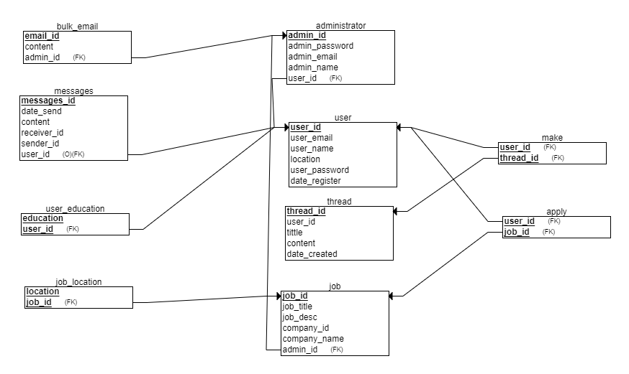
* 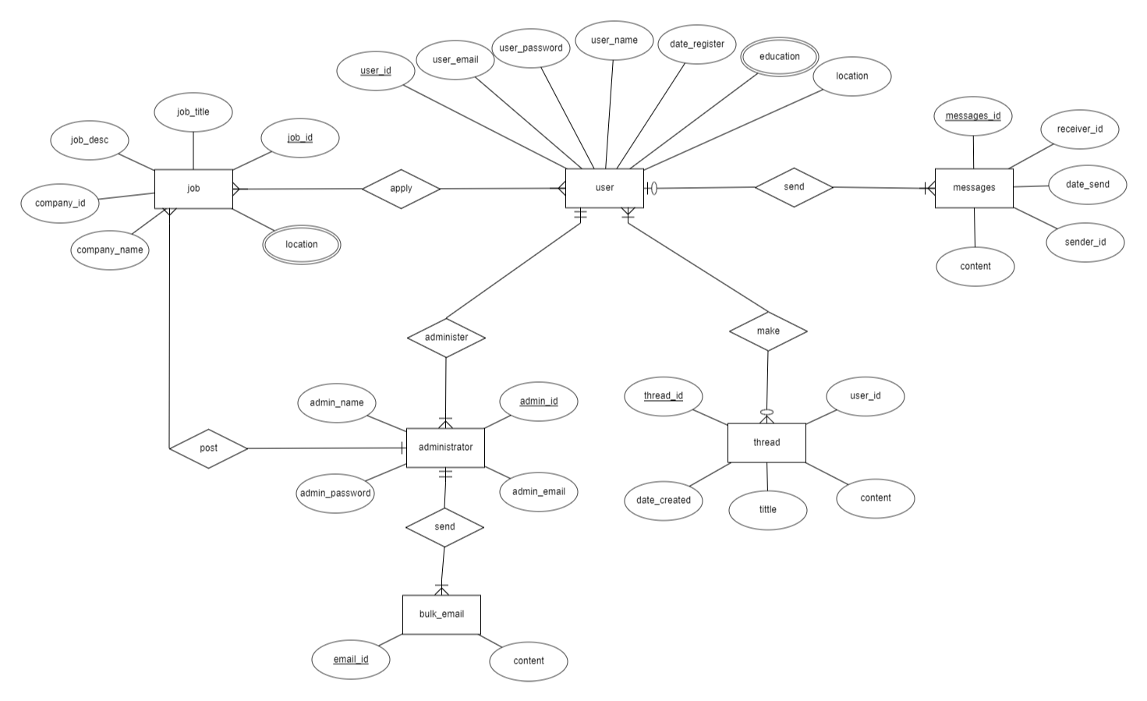

# **Prepare a detailed project plan to implement the Community Portal**

## **Wireframe**

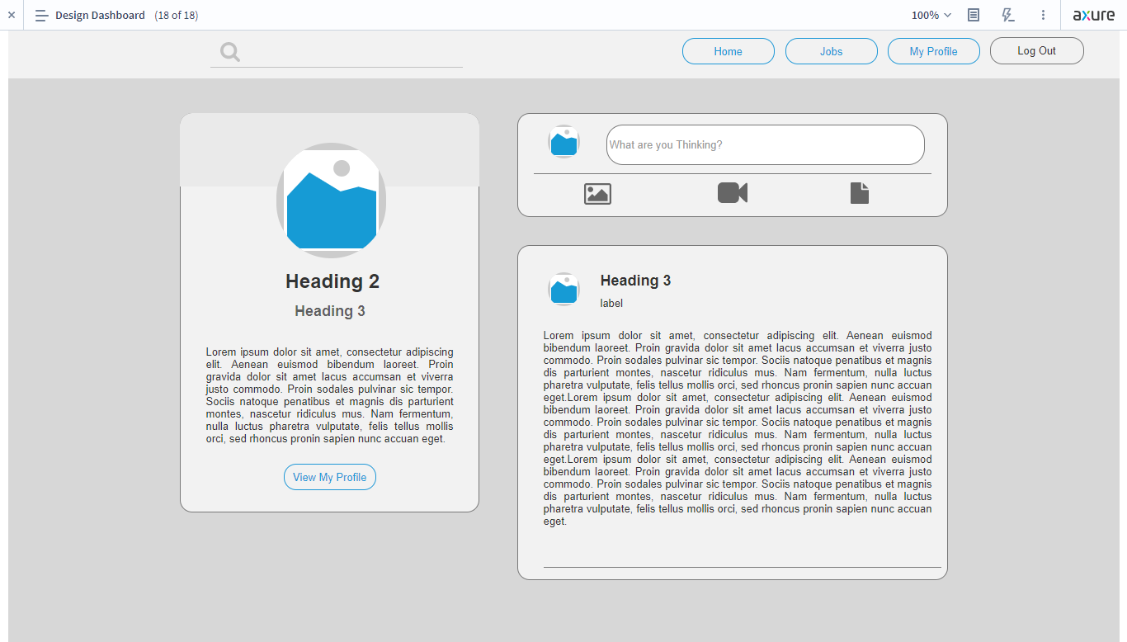

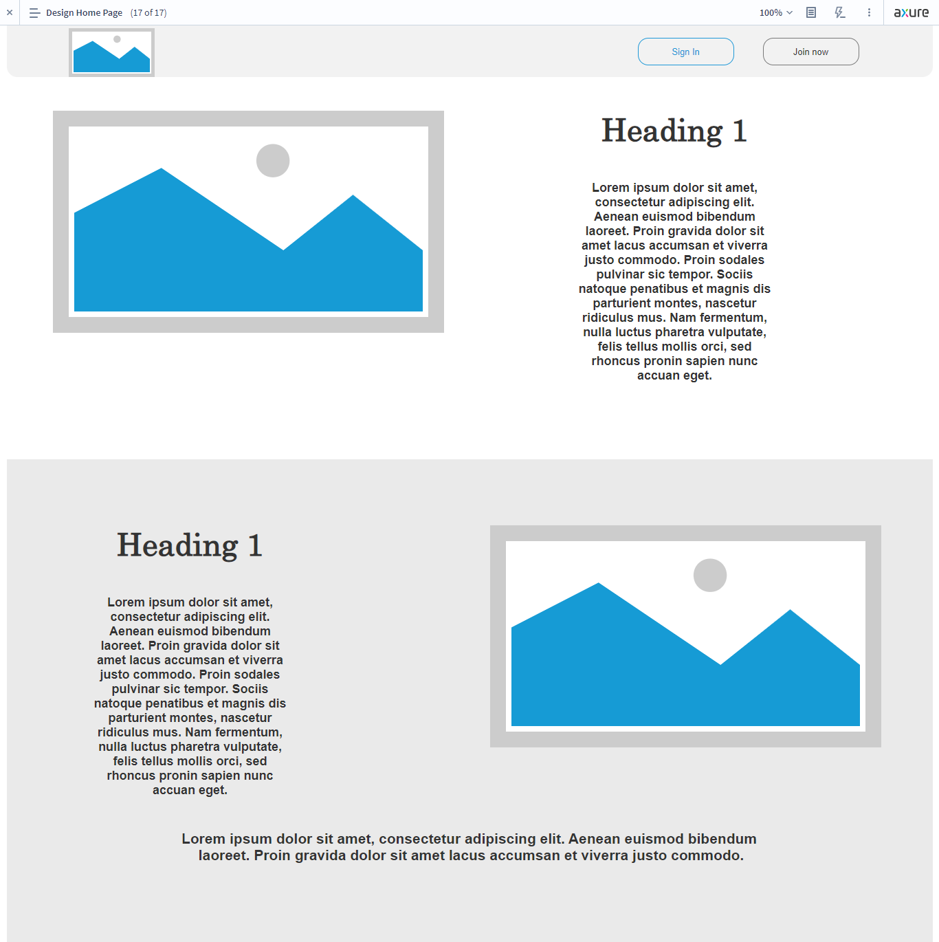

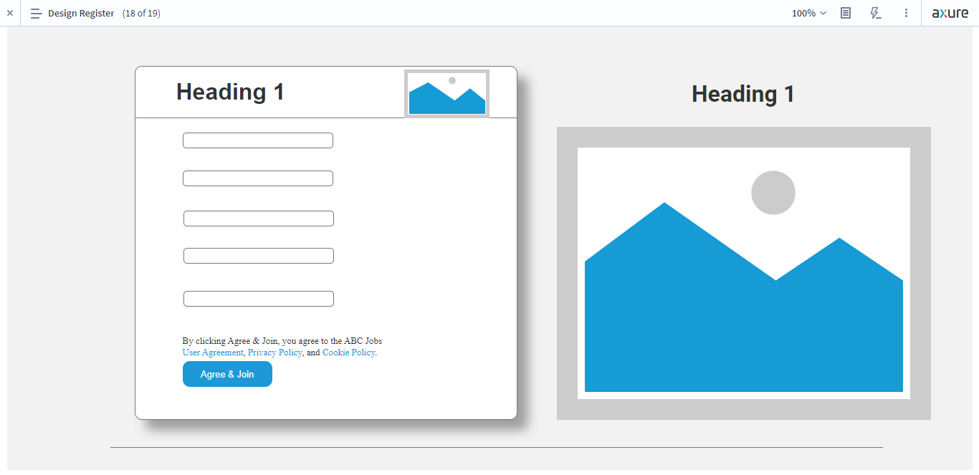

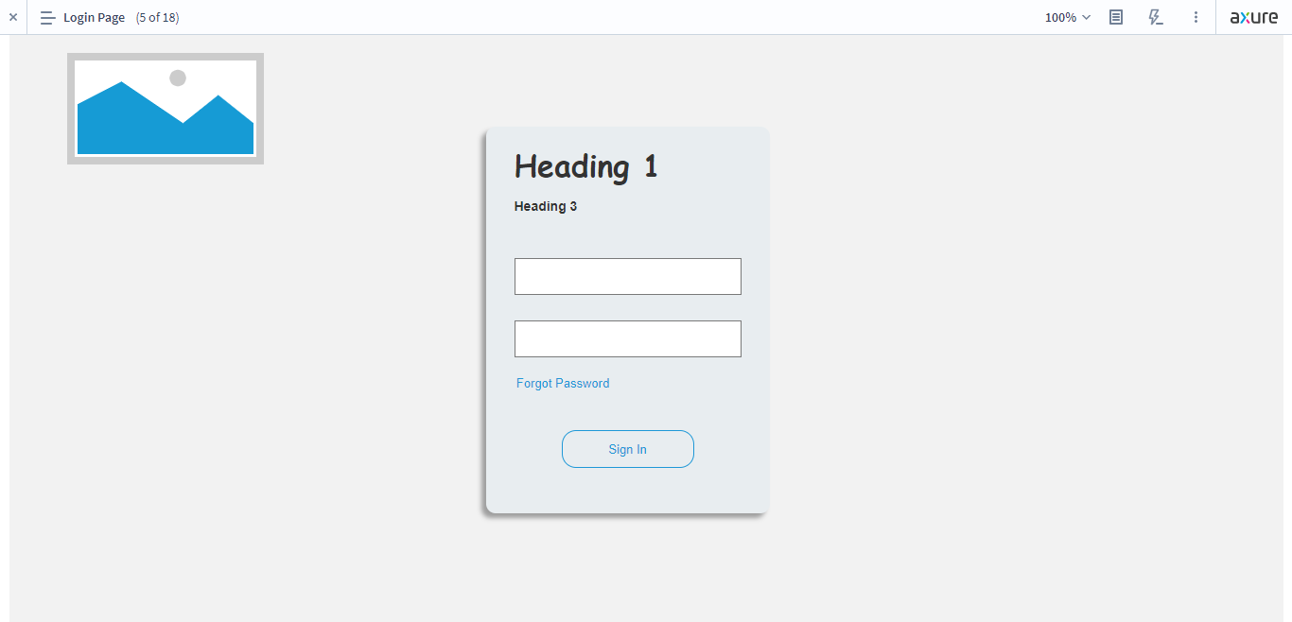

## **Stories board**

Karl is interested in looking job in the community portal. So he goes to the website. After that, click the registration button on the top right web pages. In the registration form, Karl must fulfill his full name, date of birth, gender, nationality, email, and password. After he is done, he can click agree and join button.

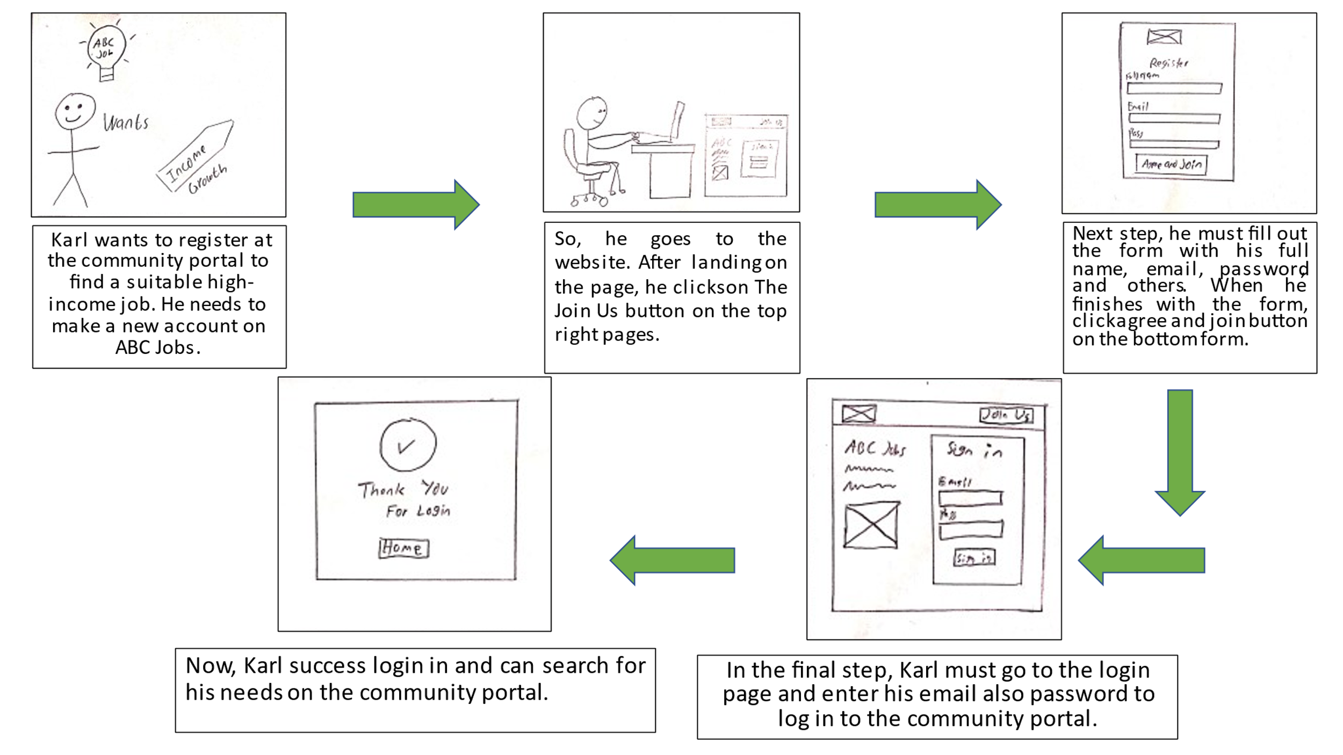

## **Persona**

|  |  |  |
| --- | --- | --- |
| No | Persona | Brief Description |
|  | Albert Wesker | Albert wants to know about the information of IT companies. |
|  | Ashley Graham | Ashley wants to advance her knowledge about the Administrator. |

|  |  |
| --- | --- |
| Persona (1): | Karl Heisenberg |
| Demographics: | * Age : 35 Years * Nationality : Germany * Gender : Male * Job : Full Stack Developer ( 7 years experience ) |
| Behaviors and Beliefs: | * IT Enthusiast * Have a dream of making self-company |
| Characteristics: | * Ambitious Person * Fast Critical Thinking |
| Goals: | * Got a suitable job for him * Have self-company |

|  |  |
| --- | --- |
| Persona (2): | Ashley Graham |
| Demographics: | * Age : 28 Years * Nationality : America * Gender : Female * Job : Fresh Graduate with a Bachelor of Computer Science |
| Behaviors and Beliefs: | * Easy to adapt to the new environment * like to multitask when doing some activity |
| Characteristics: | * Cheerful Person * Fast Learner |
| Goals: | * Have the first job in IT Industry * Become Administrator of the ABC Jobs Portal |

## **Project Plan**

### **Gantt Table**

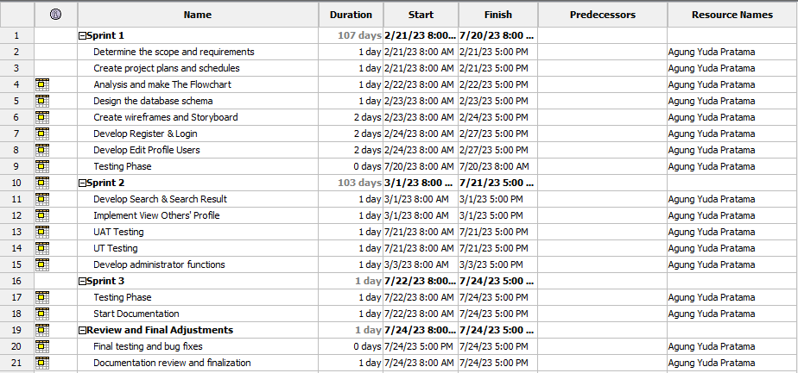

### **Gantt Chart**

